**SALESEASE**

*A WEB BASED SALES AND CUSTOMER MANAGEMENT SYSTEM (SCMS)*

**SUBMITTED BY**

**Bishal Somare**

**7-2-559-33-2021**

**Pranish Siris**

**7-2-559-45-2021**

Oxford College, Butwal

*A Project Proposal Report*

**SUBMITTED TO**

**Suraj Khattri**

in partial fulfillment of the requirement for the degree of

**Bachelor of Information Management**

Sukkhanagar-8, Butwal

December, 2024

Table of Contents

Page

1. Introduction 1

2. Problem Definition 1

3. Objectives 1

4. Scope and Limitations 1

4.1. Scope 1

4.2. Limitations 1

5. Methodology 2

5.1. Software Development Model 2

5.2. Study of Existing System 2

5.3. Requirement Analysis 2

5.3.1. Functional Requirements 2

5.3.2. Non-functional Requirements 3

5.4. Feasibility Analysis 3

5.4.1. Technical Feasibility 3

5.4.2. Operational Feasibility 3

5.4.3. Economic Feasibility 3

5.5. Tools Used 3

5.5.1. Frontend 3

5.5.2. Backend 3

5.5.3. Database 4

5.5.4. IDE For Development 4

5.5.5. Version Control 4

6. Overview of System 4

6.1. Unified Modelling Language 4

6.1.1. Use Case Diagram 4

6.1.2. Activity Diagram of Salesease 6

7. Gantt Chart for the project 7

8. Expected Outcomes 7

9. References 7

# 1. Introduction

“SalesEase” is an efficient and scalable sales and operational management system developed for the Ganapati Enterprise. This system focuses on automating key business process, streamlining sales workflows, and enhancing operational precision to meet the demands of a fast paced and competitive business environment.

# 2. Problem Definition

Ganapati enterprises struggles with inefficient inventory and sales management due to lack of an integrated system. This results in time-consuming document storage, and challenges in tracking sales and stock levels. The manual system fails to generates sales report or provide accurate sales data.

* Lack of system integration, leading to disorganized document storage .
* Difficulty in monitoring daily sales and available inventory levels.

# 3. Objectives

As most existing system provides limited functions to user, thus this project will contain enhanced and more flexiable functions to the store. The objectives include:

* To generate report on sales and inventory activities.
* To provide notifications on low level of stock.
* To generate receipt for customer references.

# 4. Scope and Limitations

## 4.1. Scope

* It focuses on enhancing efficiency in managing customer data, tracking sales transactions, monitoring inventory, and generating useful insights via dashboards.

## 4.2. Limitations

* It is designed for web-based environments, without offline access or a mobile application.

# 5. Methodology

## 5.1. Software Development Model

The Waterfall Model is selected for the development of sales and customer management system due to it’s structured and sequential approach, which is well-suited for projects with clearly defined requirements and a fixed scope.

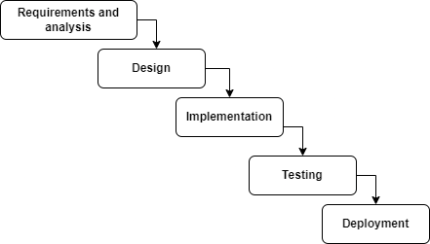

***Figure 1:WaterFall Model***

## 5.2. Study of Existing System

* Salesforce is a leading customer relationship management (CRM) platform, focusing on sales automation, marketing, and customer service. It offers customizability and advanced analytics for businesses (McCarthy, 2021).
* Zoho CRM from Zoho is a cloud-based customer relationship management (CRM) platform to manage the sales, marketing and customer support facets of business-to-business (B2B) and business-to-customer (B2C) (Houpes, 2015).

## 5.3. Requirement Analysis

### 5.3.1. Functional Requirements

* Admin can registered sales admin and inventory admin.
* Secure login for users (admin and staffs).
* Inventory admin can track real-time inventory levels.
* Admin and inventory admin can manage inventory.
* System will notify the admin when stock reach ROL.
* Admin and sales admin can view the sales history of customer and products.
* Admin and sales admin can manage customer information.
* Admin and inventory admin can manage vendor.

### 5.3.2. Non-functional Requirements

* Performance
* Security
* Usability
* Maintainability
* Reliability

## 5.4. Feasibility Analysis

### 5.4.1. Technical Feasibility

* Optimizing processing time for tasks ensures a responsive and smooth user experience.
* Designed for maintainability with clear documentation and modular components, enabling easy updates and troubleshooting.

### 5.4.2. Operational Feasibility

* The system is designed with a fully GUI-based interface, ensuring ease of use for all types of user, including non-technical staff.
* The system automates repetitive tasks such as data management, reducing manual effort and improving operational efficiency.

### 5.4.3. Economic Feasibility

* The project leverages open-source technologies, reducing licensing costs.
* Minimal hardware investment is required.

## 5.5. Tools Used

### 5.5.1. Frontend

* HTML5, CSS, Bootstrap, AJAX, JavaScript

### 5.5.2. Backend

* Django(Python)

### 5.5.3. Database

* MySQL

### 5.5.4. IDE For Development

* Visual Studio Code

### 5.5.5. Version Control

* Git
* GitHub

# 6. Overview of System

## 6.1. Unified Modelling Language

### 6.1.1. Use Case Diagram

The below use case diagram represents the interactions between different actors (users or system) and the various use cases (functionalities) of a system.

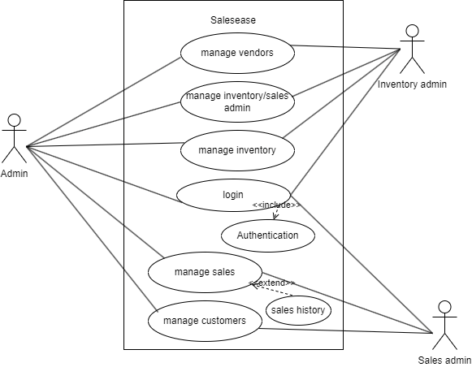

**Figure 2:Use Case Diagram of Salesease**

### 6.1.2. Activity Diagram of Salesease

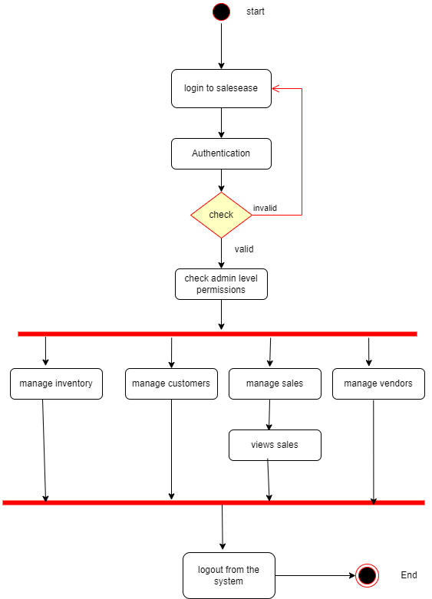

**Figure 3:Activity Diagram of Salesease**

|  |  |  |  |  |  |  |  |  |  |  |  |  |  |  |  |  |  |
| --- | --- | --- | --- | --- | --- | --- | --- | --- | --- | --- | --- | --- | --- | --- | --- | --- | --- |
| Months  Phase | December | | | January | | | | February | | | | March | | | | April | |
| II | III | IV | I | II | III | IV | I | II | III | IV | I | II | III | IV | I | II |
| Requirements and analysis |  | | |  |  |  |  |  |  |  |  |  |  |  |  |  |  |
| Design |  |  |  |  | | | |  |  |  |  |  |  |  |  |  |  |
| Implementation |  |  |  |  |  |  |  |  | | | | |  |  |  |  |  |
| Testing |  |  |  |  |  |  |  |  |  |  |  |  |  | | |  |  |
| Deployment |  |  |  |  |  |  |  |  |  |  |  |  |  |  |  |  | |
| Documentation |  | | | | | | | | | | | | | | | | |

# 7. Gantt Chart for the project

# 8. Expected Outcomes

“Sales Ease” is expected to:

* Notifications on low stock level.
* Elimination of manual data entry and reduction of errors.
* Generation of receipts for customer references.

# 9. References

Houpes, T. (2015, 8 15). *Zoho CRM platform overview*. From techtarget: https://www.techtarget.com/searchcustomerexperience/feature/Zoho-CRM-platform-overview

McCarthy, B. (2021, 3 17). *What is Salesforce & Why is it so Popular?* From salesforceben: https://www.salesforceben.com/what-is-salesforce-a-beginners-guide/